Ord. No. 98-2025
Walk to End Colon Cancer 5K Map
Start in front of Beer Head
-Left on W 11th St
-Right on Front Ave
-Right on W 9th St
-Left on W Lakeside Ave
-Left on W 3rd St
-Right on Alfred Lerner Way
TURNAROUND
-Left on W 3rd St
-Right on W Lakeside Ave
-Right on W 9th St
-Left on Front Ave
-Left on W 11th St
-Right on Old River Rd
Finish in front of Beer Head
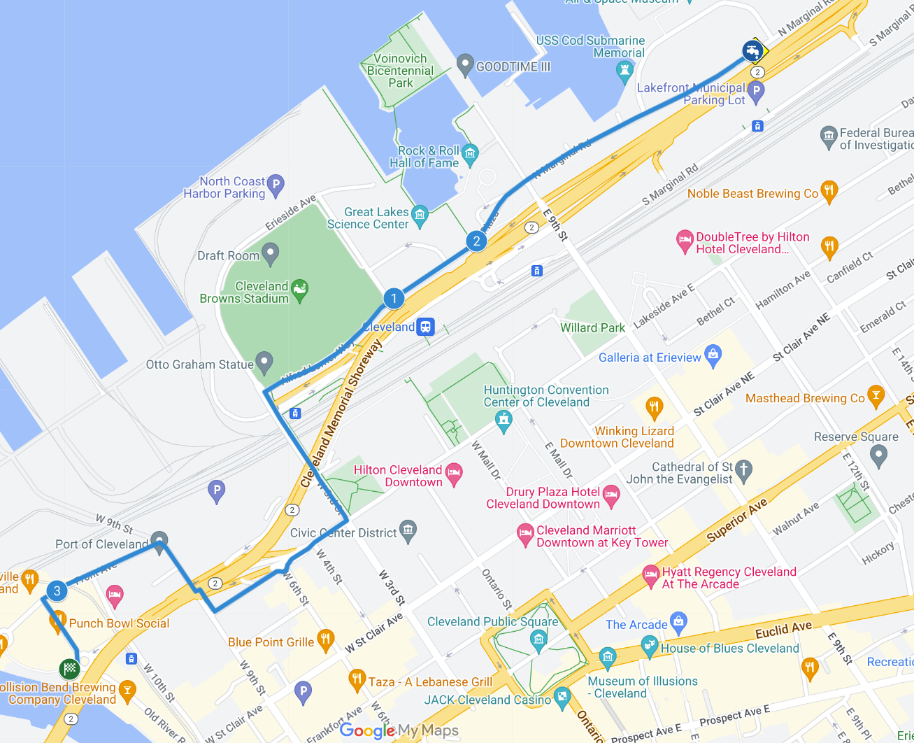



V
V
V
V
V
V

