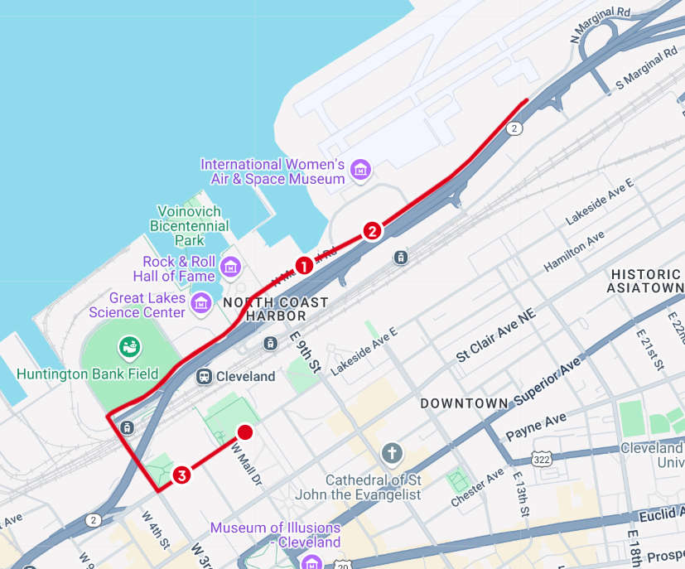
START: Lakeside Ave., across form Mall C
- Head West on Lakeside Ave.
- Turn right on West 3rd. St
- Turn right on Al Lerner Way
- Continue over East 9th St., onto North Marginal Rd.
TURNAROUND
- Continue over East 9th., onto Al Lerner Way
- Turn left on West 3rd St.
- Turn Left on Lakeside Ave
FINISH: Lakeside Ave., across from Mall C. (Same spot as start)

